Multitasking Quiz

- What is multitasking?

- How can you run a program that has the robot looking for a black line, plays a song and writes to the screen, and lift a robotic arm all at the same time?

- Ziffle writes this program to have his robot go forward until it sees a black line and then turn, all the while constantly raising and lowering its robotic arm. Ziffle is disappointed (again). What is wrong with this program?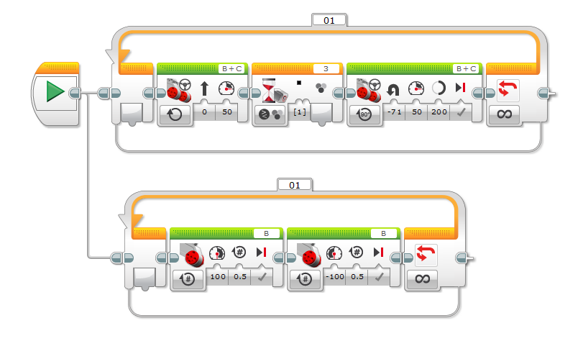

- Ziffle is having even more problems. He writes another program to stop a robots movement when the touch sensor is pressed. It’s not working. Why not?